[GOOGLE EARTH ENGINE](EE01%20Earth%20Engine%20(EE).docx) [APPLICATION PROGRAMMING INTERFACE](EE05%20%20%20The%20EE%20API.docx) [CAPABILITIES](EE07%20%20%20%20%20%20API%20Capabilities.docx)

PROCESSING **CHART** [WIDGETS](EE08%20%20%20%20%20%20%20%20%20Widgets.docx)

A chart is an EE widget object that represents graphic depictions of data in the Reporting Panel of an EE web page. Charts can be processed by using operations

of the types listed below, which vary according to the nature of that processing. Each operation name is linked to a separate page describing that operation.

**CREATING** CHARTS [chart.Chart](#Chart)

**EDITING** CHARTS [chart.setDataTable](#setDataTable)  [chart.transform](#transform) [chart.setChartType](#setChartType)

[chart.setSeriesNames](#setSeriesNames) [chart.setOptions](#setOptions) [chart.setView](#setView)

[GOOGLE EARTH ENGINE](EE01%20Earth%20Engine%20(EE).docx) [APPLICATION PROGRAMMING INTERFACE](EE05%20%20%20The%20EE%20API.docx) [CAPABILITIES](EE07%20%20%20%20%20%20API%20Capabilities.docx)

**CREATING** [CHART](#_top) [WIDGETS](EE08%20%20%20%20%20%20%20%20%20Widgets.docx)

chart.Chart creates a new chart by presenting the content of a specified two-dimensional array or Google Visualization DataTable literal.

newChart = Chart( oldArrayOrTable, *chartType, chartStyle, dataView* )

The specified array or DataTable

The dataView filtering the chart to be generated, given as one of the strings described [https://developers.google.com/chart/interactive/docs/reference#DataView](https://developers.google.com/chart/interactive/docs/reference" \l "DataView" \t "_blank)

The new chart

The type of chart to be generated, given as one of the strings

(such as 'ScatterChart', 'LineChart', and 'ColumnChart') described

at [https://developers.google.com/chart/interactive/docs/gallery](https://developers.google.com/chart/interactive/docs/gallery" \t "_blank)

The style of chart to be generated, given as one of the strings described [https://developers.google.com/chart/interactive/docs/customizing\_charts](https://developers.google.com/chart/interactive/docs/customizing_charts" \t "_blank)

ADD EXAMPLE

[GOOGLE EARTH ENGINE](EE01%20Earth%20Engine%20(EE).docx) [APPLICATION PROGRAMMING INTERFACE](EE05%20%20%20The%20EE%20API.docx) [CAPABILITIES](EE07%20%20%20%20%20%20API%20Capabilities.docx)

**EDITING** [CHART](#_top) [WIDGETS](EE08%20%20%20%20%20%20%20%20%20Widgets.docx)

chart.setDataTable creates a new chart by using the format of a specified chart to present the content of a specified DataTable.

newChart = oldChart.setDataTable( dataTable)

The specified DataTable, given as a 2-D array or a Google Visualization DataTable literal

as described at [http://developers.google.com/chart/interactive/docs/reference#DataTable](http://developers.google.com/chart/interactive/docs/reference" \l "DataTable" \t "_blank)

The new chart

The specified chart

ADD EXAMPLE

[GOOGLE EARTH ENGINE](EE01%20Earth%20Engine%20(EE).docx) [APPLICATION PROGRAMMING INTERFACE](EE05%20%20%20The%20EE%20API.docx) [CAPABILITIES](EE07%20%20%20%20%20%20API%20Capabilities.docx)

**EDITING** [CHART](#_top) [WIDGETS](EE08%20%20%20%20%20%20%20%20%20Widgets.docx)

chart.transform creates a new chart by replicating a specified chart and then subjecting its data to a specified “transformer” function.

newChart = oldChart.transform( transformer)

The specified transformer function, given as an object described at

[https://developers.google.com/chart/interactive/docs/reference?hl=ja#google.visualization.drawchart](https://developers.google.com/chart/interactive/docs/reference?hl=ja" \l "google.visualization.drawchart" \t "_blank).

This object may include

- a specified DataTable, given as a 2-D array or a Google Visualization DataTable literal

as described at [http://developers.google.com/chart/interactive/docs/reference#DataTable](http://developers.google.com/chart/interactive/docs/reference" \l "DataTable" \t "_blank) ;

- a specified ChartType, given as one of the strings (such as 'ScatterChart', 'LineChart', and

'ColumnChart') described at [https://developers.google.com/chart/interactive/docs/gallery](https://developers.google.com/chart/interactive/docs/gallery" \t "_blank)

- a specified ChartStyle, given as one of the strings described

[https://developers.google.com/chart/interactive/docs/customizing\_charts](https://developers.google.com/chart/interactive/docs/customizing_charts" \t "_blank) ; and/or

- The specified DataView, given as one of the strings described at

[https://developers.google.com/chart/interactive/docs/reference#DataView](https://developers.google.com/chart/interactive/docs/reference" \l "DataView" \t "_blank)

The new chart

The specified chart

ADD EXAMPLE

[GOOGLE EARTH ENGINE](EE01%20Earth%20Engine%20(EE).docx) [APPLICATION PROGRAMMING INTERFACE](EE05%20%20%20The%20EE%20API.docx) [CAPABILITIES](EE07%20%20%20%20%20%20API%20Capabilities.docx)

**EDITING** [CHART](#_top) [WIDGETS](EE08%20%20%20%20%20%20%20%20%20Widgets.docx)

chart.setChartType creates a new chart by presenting the content of a specified chart in a newly specified style.

newChart = oldChart.setOptions( chartStyle)

The specified style, given as one of the strings described [https://developers.google.com/chart/interactive/docs/customizing\_charts](https://developers.google.com/chart/interactive/docs/customizing_charts" \t "_blank)

The specified chart

The new chart

var TheIMAGE = ee.Image( 'CGIAR/SRTM90\_V4' );

var TheFEATURES = ee.FeatureCollection('ft:1fRY18cjsHzDgGiJiS2nnpUU3v9JPDc2HNaR7Xk8'); // U.S. States

var TheFEATURES = TheFEATURES.filterMetadata('Name','contains','New');

var TheCHART = Chart.image.byRegion( TheIMAGE, TheFEATURES, ee.Reducer.mean(), 1000, 'Name');

var TheCHART = TheCHART.setOptions( { title:'Mean Elevation by State',

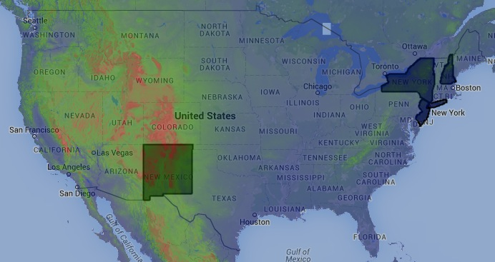 hAxis:{ title: 'Selected States' },

vAxis:{ title: 'Elevation'} } );

var TheCHART = TheCHART.setChartType('LineChart'); print( TheCHART );

var TheCHART = TheCHART.setChartType('ColumnChart'); print( TheCHART );

var TheCHART = TheCHART.setChartType('BarChart'); print( TheCHART );

var TheCHART = TheCHART.setChartType('AreaChart'); print( TheCHART );

var TheCHART = TheCHART.setChartType('PieChart'); print( TheCHART );

var TheCHART = TheCHART.setChartType('Gauge'); print( TheCHART );

Map.centerObject( TheFEATURES,4 );

Map.addLayer( TheFEATURES, { color:'000000', opacity:0.1 }, 'The States' );

Map.addLayer( TheIMAGE, { min:0, max:3000, opacity:0.5, palette: ['000099','00aa00','ff0000'] }, 'Elevation' );

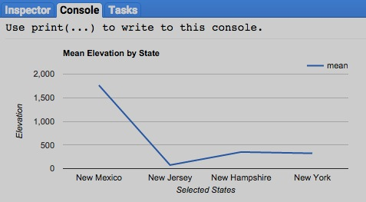

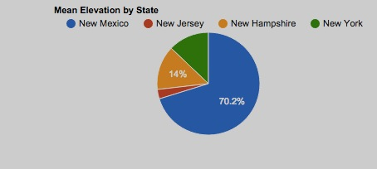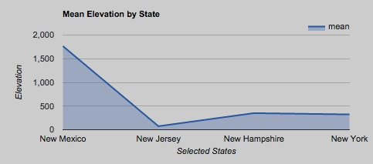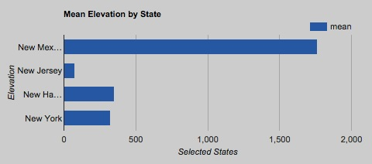

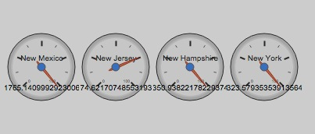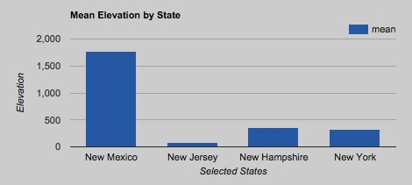

[GOOGLE EARTH ENGINE](EE01%20Earth%20Engine%20(EE).docx) [APPLICATION PROGRAMMING INTERFACE](EE05%20%20%20The%20EE%20API.docx) [CAPABILITIES](EE07%20%20%20%20%20%20API%20Capabilities.docx)

**EDITING** [CHART](#_top) [WIDGETS](EE08%20%20%20%20%20%20%20%20%20Widgets.docx)

chart.setSeriesNames creates a new chart by replicating a specified chart but specifying a new set of series names.

newChart = oldChart.setSeriesNames( seriesNames*, seriesIndex* )

The ordinal position of the series whose name is to be replaced when

**seriesNames** is specified as a string, given as an integer beginning with 0

The specified series name(s), given either as a list of strings (in which case, those string are applied according to their order) or as a string (in which case, that string replaces the one name identified by **seriesIndex**

The new chart

The specified chart

var TheARRAY = ee.Array( [ [ 0, 1, 2, 3],

[ 10, 11, 12, 13],

[ 20, 21, 22, 23] ] );

var TheCHART = Chart.array.values( TheARRAY, 1, [0,1,2,3]);

var TheCHART = TheCHART.setOptions( { title: 'Arrayed Values',

hAxis: { title: 'Array Columns' },

vAxis: { title: 'Array Value' } } );

var TheCHART = TheCHART.setSeriesNames( ['Array Row 0','Array Row 1','Array Row 2'] );

print( TheCHART );

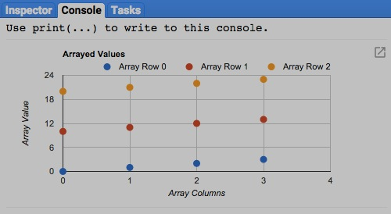

[GOOGLE EARTH ENGINE](EE01%20Earth%20Engine%20(EE).docx) [APPLICATION PROGRAMMING INTERFACE](EE05%20%20%20The%20EE%20API.docx) [CAPABILITIES](EE07%20%20%20%20%20%20API%20Capabilities.docx)

**EDITING** [CHART](#_top) [WIDGETS](EE08%20%20%20%20%20%20%20%20%20Widgets.docx)

chart.setOptions creates a new chart by replicating a specified chart but specifying a new set of charting options.

newChart = oldChart.setOptions( settings)

The specified options, given as a dictionary of items that are fully described at [https://developers.google.com/chart/interactive/docs/customizing\_charts](https://developers.google.com/chart/interactive/docs/customizing_charts" \t "_blank)

The specified chart

The new chart

var SatelliteIMAGES = ee.ImageCollection('LANDSAT/LC8\_L1T\_8DAY\_TOA').filterDate('2014-01-01','2014-12-31');

var SatelliteIMAGE = SatelliteIMAGES.median().select( ['B1','B2','B3','B4','B5','B6','B7'] );

var CityFEATURES = ee.FeatureCollection( 'ft:1G3RZbWoTiCiYv\_LEwc7xKZq8aYoPZlL5\_KuVhyDM' ).limit(3); // U.S. Cities

var OldCHART = Chart.image.regions( SatelliteIMAGE, CityFEATURES, ee.Reducer.mean(), 30, 'city\_name');

var NewCHART = OldCHART.setOptions( { title: 'Mean Band Reflectance by City',

hAxis: { title:'Landsat Bands' },

vAxis: { title:'Reflectance Values'},

pointShape: { type:'star', sides:5 },

pointSize: 7,

lineWidth: 2,

series: { 0:{color: '#aaaaaa'}, 1:{color:'lightblue'}, 2:{color:'#00ff00'} },

}

);

print( OldCHART, NewCHART );

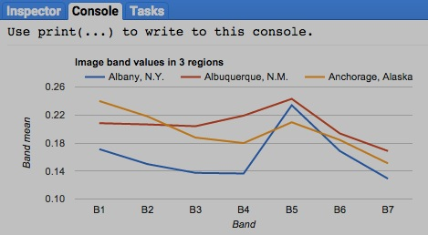

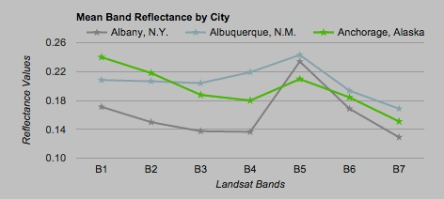

[GOOGLE EARTH ENGINE](EE01%20Earth%20Engine%20(EE).docx) [APPLICATION PROGRAMMING INTERFACE](EE05%20%20%20The%20EE%20API.docx) [CAPABILITIES](EE07%20%20%20%20%20%20API%20Capabilities.docx)

**EDITING** [CHART](#_top) [WIDGETS](EE08%20%20%20%20%20%20%20%20%20Widgets.docx)

chart.setView creates a new chart by presenting the content of a specified chart as filtered by a newly specified dataView.

newChart = oldChart.setView( dataView)

The specified dataView, given as one of the strings described [https://developers.google.com/chart/interactive/docs/reference#DataView](https://developers.google.com/chart/interactive/docs/reference" \l "DataView" \t "_blank)

The specified chart

The new chart

ADD EXAMPLE